Care & Health Improvement Programme Update

Purpose of report
For information.
Summary
- This report provides an update on adult social care improvement matters and the Care and Health Improvement programmes.

Recommendation
- That the Improvement and Innovation Board is asked to note the report and provide direction and advice on the Care and Health and adult social care improvement programmes.

Contact officer: Simon Williams / Andrew Hughes
Phone no: 07 500 815 710 / 07 909 534185
Email: Simon.Williams@local.gov.uk / Andrew.Hughes@local.gov.uk

Background
- This paper provides an update on adult social care and public health improvement support issues and an operational update on the Care and Health Improvement Programmes (CHIP).

Care and Health Improvement Programme
- The Care and Health Improvement Grant has now been agreed with the Department of Health (DHSC) in 2021/22 and is with the Department for final internal processes. The PowerPoint slides at Annex 1 were presented to the DHSC CHIP Grant Assurance Meeting in early September. It takes the format of a pilot Ministerial Report that will be used in future reporting quarterly reporting.
- Improvement and Innovation Board will note that there are no targets set in this grant agreement, but there are linkages to the social care assurance discussions (see later) and a clear desire from the former Minister of State for Care to have greater direction, oversight and information from the Programme. We expect this to continue with the new Minister.
Other Programmes
- The LGA has secured a range of other agreements with the DHSC, NHS bodies, Public health England and The Health Foundation to run a range of other adult social care and public health improvement support programmes. These are shown at Annex 2.

Adult Social Care Improvement Update
Reform
- CHIP supports LGA policy colleagues to influence the direction and pace of reform, and some discussions have taken place with ministers and senior civil servants. Pending any longer-term decisions on funding, the social care sector continues to rely on one off and often hypothecated grants. We highlight the impact of this on the various areas of improvement work we do.
- Alongside considerations of funding, we continue to work with partners on our vision of what a transformed and properly funded social care system might look like. What was set out in the LGA Green Paper in 2018 is still highly relevant and creates a lot of common ground.
- The Government has recently made a number of announcements on the reform of adult social care. The Community Wellbeing Board is managing the policy response to those reforms. These include:
  - Implementing a version of the Sir Andrew Dilnot reforms originally set out in the Care Act 2014;
  - Proposing a Social Care White Paper for the autumn that is likely to set out the reforms to the adult social care system with particular reference the social care workforce, the use of care technologies and housing; and
  - The integration of social care and health, through the proposals set out in the existing Health & Care Bill
- A Delivery Board, with representatives from the LGA and others, has been established by DHSC to oversee the implementation of the Dilnot reforms. We have also been invited to co-produce the White Paper.
Assurance and improvement
- CHIP works alongside policy in engaging with DHSC and the Care Quality Commission (CQC) in the design of regulation over local authority commissioning and delivery functions, through a senior group and a supporting design group. There has been an open exchange of ministerial and local government bottom lines. We have been especially keen to emphasise continued local accountability to elected members as the bedrock of “assurance”, not least because social care is now funded mostly from local taxation, and the continued role of sector led improvement.
- Regarding improvement, we have been clear about its essential role and its track record, and this is supported by both DHSC and CQC.
- CQC has worked with us in developing its own proposals for oversight, which seek to allow councils to continue to take responsibility for their own improvement and outcomes for local people, and to target more detailed scrutiny for places where it is needed.
- We are in discussion with DHSC about their proposals for how and when intervention from the Secretary of State may happen.
- The sector agrees with DHSC that all this will need a much-improved data offer, and recently we have discussed with them an outline for a rounded data and intelligence strategy.
Whole systems working
- We continue to support a range of work for councils and their NHS partners focused on hospital admissions avoidance and effective discharge from hospital. This includes the development of a new High Impact Change Model for preventing avoidable admissions to hospitals and care homes, which is now in use, and the development of a similar model looking at homelessness and housing.
- We are working with the NHS and central government on continued policies for hospital discharge, community-based support, and increasingly mental health services. Whilst supporting the continued bespoke funding for Discharge to Assess in order to avoid a cliff edge drop in funding in September, we are also working with the NHS to identify and address variation in
- We are delivering an increasing number of bespoke support packages for local systems, often about discharge from hospital but increasingly around other issues like admissions to hospital. We continue to use the model of short (a day or half day) interventions for leadership teams, so that we can repeat them if needed, alongside longer peer reviews.
Integrated Care Systems and systems leadership
- An increasing area of our work is now spent supporting councils to contribute to the integrated Care Systems. While the government has investigated significantly in preparing the NHS for the introduction of ICS there has been no similar investment in local authority development. We have secured a contribution to the NHS programme.
- Learning from our recent series of events on the introduction of Integrated Care Systems has highlighted some concern from council Leaders, Chairs of Health & Wellbeing Boards and Chief Executives about the speed of their introduction and their own capacity to engage at pace with the new ICSs and ICPs.
Commissioning and provider markets
- We are developing a dashboard for councils to self-assess their own positions on commissioning and market influence, which will support the other major piece of strategic work around helping councils go through a structured options appraisal process when planning their commissioning intentions.
- We are also supporting councils and providers in specific areas such as a model for the cost of care, finding affordable insurance, and assessing provider viability.
Workforce
- At present we are out to tender to develop a framework for strategic workforce planning, with the aim that this will be a live tool for use by councils together with their providers. This has emerged as an overall need following a series of regional workshops.
- Alongside this, we are engaged in supporting councils to meet some immediate and acute workforce pressures, with providers saying it is worse than it has been for years. We have a menu of options including top tips for recruitment and retention, supporting wellbeing, and what commissioners can do to alleviate pressures. We are also engaged with DHSC on policy options relevant to this which can worsen or mitigate the risks, including isolation requirements, forbidding movement between settings, and the impact of mandatory vaccination.

Innovation and technology
- Alongside the work with NHSX as described below, we are continuing to share good practice between councils, to support specific areas of innovation and redesign support, and to ensure that local authorities have their own space to discuss technology and innovation.
- We continue to align our social care digital work alongside that of NHSx, who lead the DHSC in this area ensuring that we have a strong voice within NHSx and NHSD advocating for social care across their Programmes. We appoint the National Strategic Adviser within NHSx. The focus of our joint work is to:
  - input and influence into the longer-term strategic planning for JUC ensuring the needs of adult social care are taken into account;
  - support councils to sustainably adopt digital technology that transforms health and wellbeing for their residents; and
  - inputting into NHSx submissions for the spending review, data strategy, social care reforms
- In addition, we are in discussions with NHSD to restart and scale up the Social Care Digital Innovation Programme from next year.
Use of resources
- Much of the targeted work has been to support authorities with acute financial pressures, along with other bespoke support to councils; it is noteworthy that increasingly the pressures and opportunities for savings are from working age adults which also has a dependency on transitions from children’s services.
- There has been some technical advice given on issues such as finance returns this year, and support to councils responding to the judgement concerning Norfolk’s charging policy for working age adults.
Social Care Information Governance
- There has been a significant increase in the range of social care information governance issues coming to the attention of the LGA particularly with regards to data sharing between health and care and the establishment of Integrated Care Systems.
- The LGA has seats on the National Data Guardian Panel and the Health and Care Information Governance Group (both sponsored by NHSx) and has recently responded to the consultation on the draft NHS data strategy, ‘Data Saves Lives’, to support the general thrust of the strategy and stress the need for a focus on prevention and for financial support to councils and care provider to implement the strategy.
Liberty Protection Safeguards (LPS)
- Our work to support the introduction of LPS, a replacement of the Deprivation of Liberty Safeguards, is now gaining momentum. We are supporting the introduction across Children’s and Adult’s Services and co-ordinating with the NHS, who will also implement the legislation.
- The programme is closely linked to the DHSC consultation on the LPS regulations and its decision on a start date for the new legislation. Consultation is now expected in the late summer.
People with learning disabilities and autism
- There continues to be a focus on the group in specialist hospitals, including helping to avoid admissions, facilitate discharge, build good community services, and commission in a person-centred way. We have been asked to support the work of the newly formed Board (chaired by the minister for social care) to oversee Building the Right Support as it is now called. We have also needed to support local government in its response to the CQC findings about restraint/seclusion/segregation in hospitals and care homes.
- More generally we are focussing on rolling out a framework on commissioning support in a way that promotes independence and offers value for money.
Covid19
- CHIP staff support to the Covid Response and Coordination Team ends in August. Continuing adult social care and public health covid-19 issues will be picked up within relevant parts of the CHIP Team with a resource identified to support those social care issues that don’t have a natural home.
- A key ongoing issue is vaccination: the implementation of the mandated scheme for care home staff, expectations of councils to support and report on take up and helping to build a delivery system for the autumn which has to combine completion of the first wave of vaccinations, boosters, and seasonal flu.
- Other continued issues include infection control (continued funding and what is expected in areas such as visiting into care homes or staff movement between settings).

Public Health Improvement Update
Public Health SLI
- Further meetings with DHSC on a public health sector improvement offer have now taken place. The offer has been refined to focus more on priorities around healthy weight management, drugs and alcohol abuse, sexual health and smoking and strengthening relationships with the Office for Health Promotion (the replacement for PHE within DHSC). We have had confirmation from DHSC that this proposal will be put forward as part of the DHSC Spending Review submission.
- The recent report from Carole Black on drugs and substance misuse supported the need for a sector improvement programme run by the LGA and this recommendation has been accepted by the Government.
Vaccination Support Programme
- The LGA has been asked to support the national NHSE Vaccination Deployment Programme. It draws on local government expertise to encourage and promote vaccine take-up, including for underserved populations, with the objectives of:
  - Providing opportunities for enhanced understanding of local government and its further potential within the national vaccine programme;
  - Supporting councils to engage with the vaccine programme at a regional/local/ICS level; and
  - Supporting improved take up within the social care sector
Shaping Places for Healthier Lives
- The Shaping Places for Healthier Lives programme delivered with The Health Foundation has now moved to its final stage. In this stage 5 councils (Bristol, Doncaster, Newham, Northumberland and Shropshire) will be supported and funded for three years to explore a system-wide approach to improving the wider determinants of health. The programme also includes a wider package of shared learning, events and learning exchanges for all local authorities.
Childhood Obesity
- The Childhood Obesity (healthy weight) programme is now moving into its final year. Most councils have continued to develop their programme throughout Covid19, although some have struggled significantly given the pressures on public health departments. Learning from this will be taken forward into the next iteration of the Government’s healthy weight strategy.
Equalities implications

- The CHIP programme seeks to ensure EDI aims are met operationally, for example through recruitment practices, media accessibility, representation at events, meetings, project boards and procurement panels.

Annex 1: Quarter 1 & 2 Ministerial Assurance Dashboard
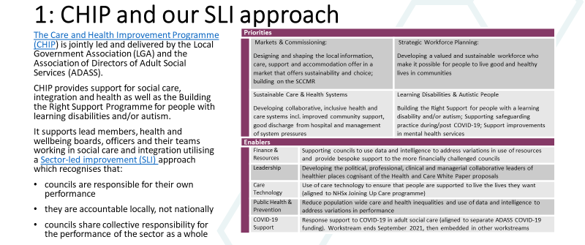
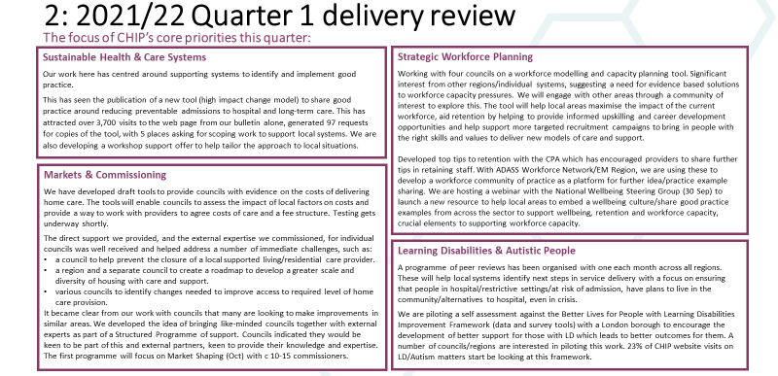
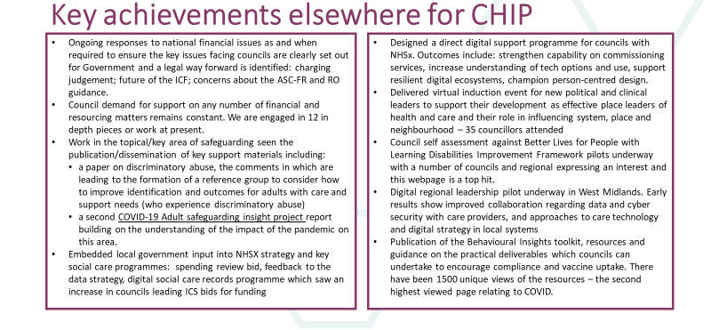
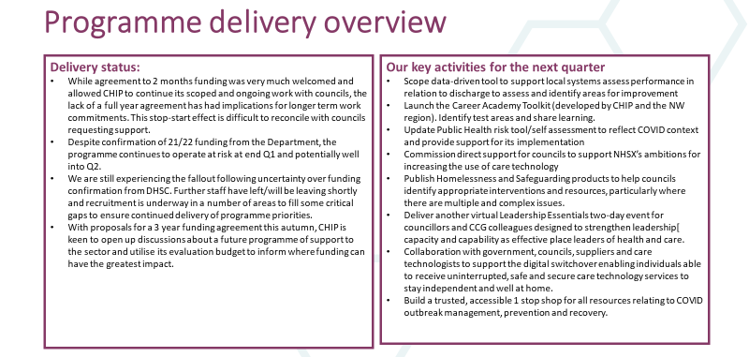
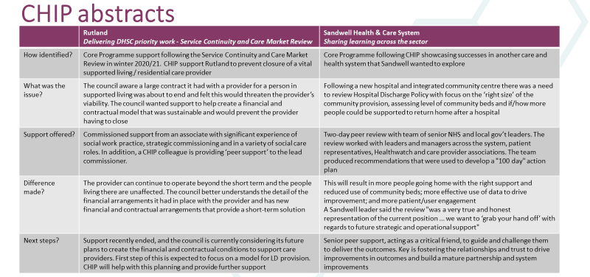
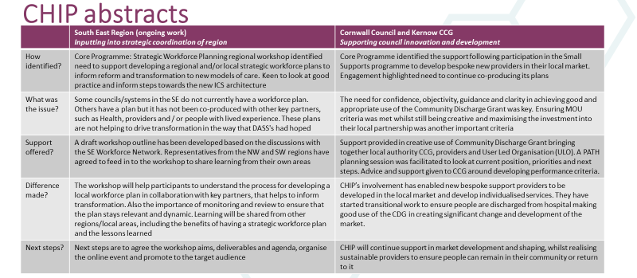
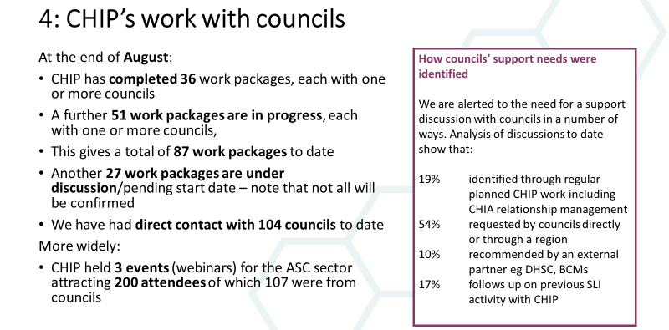
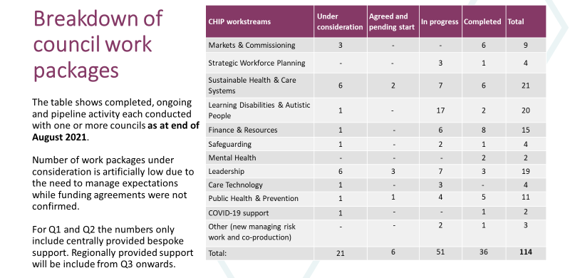
Annex 2: Care & Health Improvement Programmes
Programme | Grant description | Funder
Care and Health Improvement Programme (with ADASS) | Provide SLI support to councils across commissioning, workforce, systems design, LD/autism services, PH/prevention, leadership, service design and finance | DHSC and NHSx
Liberty Protection Safeguards | Support the implementation of LPS though: training support | DHSC
Better Care Fund Support Fund | Bespoke support on BCF and wider integrated care delivery including housing, preventing admissions, Home First and discharge to assess | Better Care Team (DHSC, NHSE/I, DLUHC)
Childhood Obesity | Supporting cross-sector action to tackle childhood obesity. Five projects: Birmingham, Bradford, Lewisham, Notts, and Pennine Lancashire | DHSC
Suicide Prevention | Bespoke support to councils to deliver suicide prevention initiatives, build capacity, tools and events | DHSC
Building the Right Support | Improving the commissioning of care and support for LD/autistic people. Focus on peer reviews, intensive support and work with local small supports organisations | NHSE/I
Place-based Partnerships Implementation Programme | Implementing place-based partnerships and developing population health management approaches | NHSE/I
System Transformation Peer Support Programme | ICSs and place-based partnerships, whole-system change | NHSE/I via NHS Provider
Shared Outcomes Fund | Discharge support model for those experiencing homeless; bespoke support, action learning sets, webinars | DLUHC/DHSC
Shaping Places for Healthier Lives | Support to create conditions for better health by funding local partnerships to take system-wide action on the wider determinants of health. Councils TBC | The Health Foundation
Social Care Vendor |  | NHSE/I

https://www.local.gov.uk/lives-we-want-lead-lga-green-paper-adult-social-care

